**Django Development Part 3**

# **Class-based Views**

On your *views.py*, import classes from generic module provided by Django:

from django.views.generic import ListView, DetailView, CreateView, UpdateView, DeleteView

* ListView – class use for displaying all data from the database (Tabular)
* DetailView - class use for displaying all information from specific data based on id
* CreateView - class use for displaying form inputs to allow user input to save in the database (Form)
* UpdateView – same as DetailView but this will be used for displaying all data into its inputs (textbox) allowing the user to update information before submitting to database.
* DeleteView - class use for confirmation view before removing some data.

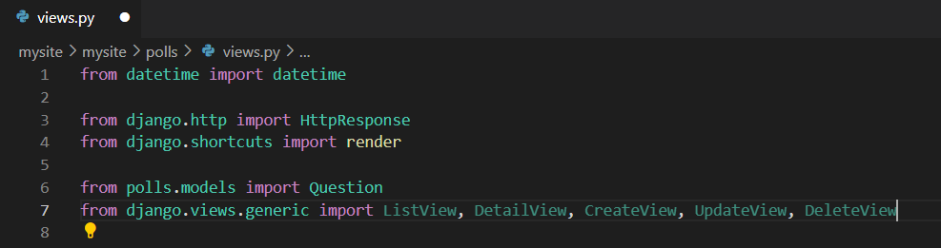

Now, modify our views

We will also modify our Urls

Now, in our Template, we will used the variable called **object_list** to extract the data from out model

## **Django Forms**

Inside of our app, create python file called forms.py

Inside of our forms.py, **import** the model and create form for Question model.

We will used the form in our views and modify the “Add Question”

Import the Form inside Views:

Import also a variable from Django url

from django.urls import reverse_lazy

Let’s modify our views and urls:



Template

Inside of our template, you can generate complete form using ` {{ form.as_p }} `

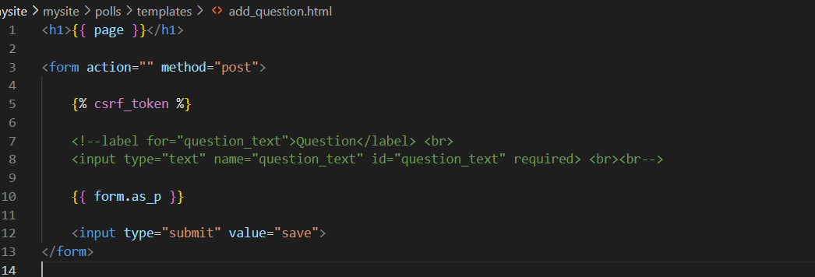

If you want to remove the date published from the form. Edit your Forms.py and removed the fields.

fields = ['question_text', 'pub_date']

Example:

fields = ['question_text']

**OTHER VIEWS**

Update:

class update_question(UpdateView):

    model = Question

    form_class = QuestionForm

    success_url = reverse_lazy('view_questions')

    template_name = 'update_question.html'

Detail:

class QuestionDetailView(DetailView):

    model = Question

    template_name = 'questiondetail.html'

Delete:

class delete(DeleteView):

    model = Question

    success_url = reverse_lazy('view_questions')

    template_name = 'questions _confirm_delete.html'

